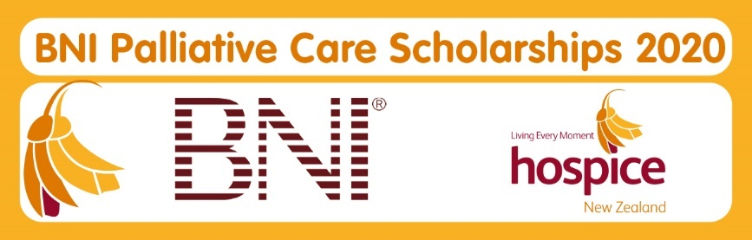

BNI® PALLIATIVE CARE SCHOLARSHIPS 2020

Hospice NZ is committed to growing leaders in hospice palliative care. Thanks to the ongoing support and generosity of our national partner BNI® New Zealand, we are delighted to offer study scholarships for 2020.

The scholarships are focused on supporting the professional development of psychosocial and allied health staff employed by hospices who are members of Hospice NZ.

Scholarship applicants must show the relevance of their chosen study to their psychosocial/allied health role and ongoing professional development needs within hospice palliative care.

The scholarships will cover tuition/ course fees up to $1000 for postgraduate study provided by an accredited institution. Applications for larger course fee costs will be judged on a case by case basis.

Applications meeting the criteria will be considered by the Hospice NZ education committee.
Criteria & conditions
- All expenses outside tuition/course fees related to the study are the recipient’s responsibility.
- Scholarships will be paid direct to the member hospice or student upon evidence of payment and enrolment.
- Each scholarship is available for study undertaken from 1 January 2020 to 31 December 2020 and must only be used for the approved course of study.
- Applicants must be New Zealand citizens or permanent residents.
- If you are eligible to apply for Health Workforce NZ/ CTA funding via a DHB you must do so before applying for a BNI scholarship for this course of study,
- Applicants must complete all sections of the scholarship application form; and include the supporting material listed.

Timelines

Applications will close at 5pm on Friday 29 November 2019.

Successful applicants will be notified by Friday 13 December 2019.

We will then require written confirmation and formal acceptance by Friday 10 January 2020.

APPLICATION FOR BNI® PALLIATIVE CARE SCHOLARSHIP 2020
Full Name:

ELIGIBILITY

I am employed by: (insert member hospice here)

Position/role: (details) |  |  | Full Time |  |  |  | Part Time (number of hours)
 |  |  | Volunteer (details)
Length of time in current position/role:
OR I am a current individual member of Hospice NZ
Citizenship: | New Zealand Citizen |  |  | NZ Permanent resident

FUNDING
Are you eligible for Health Workforce NZ/ CTA funding via a DHB for this course of study?*
*If you are eligible to apply for this funding, you must apply for it before applying for the BNI Palliative Care Scholarship funding
Yes |  |  |  |  | No
If yes, what was the outcome of your application?
Successful |  |  |  |  | Unsuccessful (please comment)
Have you received a BNI Palliative Care Scholarship previously?
Yes (provide date/year) |  |  |  |  | No

COURSE OF STUDY
I would like to apply for a scholarship to study (please attach details and documents to application)
Course title:
Provider:
Location:
Enrolment: |  | I have not yet enrolled into the above course |  |  |  | I have already enrolled in my chosen study and understand that this scholarship will provide reimbursement upon proof of payment and enrolment
CONTACT DETAILS
Postal address:

Daytime contact telephone number:
Evening contact telephone number:
Mobile number:
Email:
Please select your preferred method to be contacted:
Telephone (Daytime) |  |  |  |  | Telephone (Evening)
Mobile: |  |  |  |  | Email:

Please include the following with your application:
- A copy of your current CV.
- A cover letter telling us why you would like to receive a scholarship, including your career development and personal goals. Please include a short statement on how you expect this study will improve and impact on your professional practice and role.
- A letter from your employer endorsing your application to take leave to attend this study.
- Supporting documentation on your chosen course/ provider.

Applicant’s declaration

To the best of my knowledge all information given in this application is true and correct.
I understand that this scholarship covers study/course related fees only
I understand the Hospice NZ education committee’s decision is final and no correspondence will be entered into.
If successful, associated costs are my responsibility (e.g. travel, accommodation etc.).
The scholarship is not transferrable and must be used by the applicant named on the form.
If I am successful in my application, upon acceptance I agree to:
- enrol in and complete the chosen course of study
- notify Hospice NZ immediately if I am no longer able to complete the study
- reimburse Hospice NZ the entire scholarship amount if the study is not completed
- be contacted by Hospice NZ and BNI via my contact details provided
- my name being published and making myself available for publicity purposes, for such things as but not exclusive to, newsletters and social media
- provide a verbal or written report to colleagues and make it available to distribute to a wider network (with the support of Hospice NZ), within six months of the completion of study
- provide feedback on my study at the request of Hospice NZ on the completion of the study
- understand that if my application is successful but circumstances mean I can no longer undertake the chosen study I must notify Hospice NZ as soon as possible after the decision is made to withdraw from the course
- understand if I begin the study but am not able to complete the requirements, I must notify Hospice New NZ immediately and at their discretion, may be required to repay the scholarship amount in full.
Name of applicant (please print)
…………………………………………………………………………………..
Signature of applicant: ……………………………………Date: ……………………...
Completed applications to be emailed to kate@hospice.org.nz by
5pm on Friday 29 November 2019

